Hybrid Deep Learning Framework for Intelligent Plant Disease Detection using Leaf Image Analysis

¹P. Anitha Sahaya Mercy, ²Packiaraj.H, ³S. Angel Nithya ⁴M. Antro Monica Sanjas, ⁵S.G. Santhiya
^{1,3,4,5}Assistant Professor, Computer Science and Engineering (AI&ML), Loyola Institute of Technology & Science, Thovalai, Kannyakumari, Tamilnadu, India
²Assistant Professor, Department of Information Technology, Loyola Institute of Technology & Science, Thovalai, Kannyakumari, Tamilnadu, India

ABSTRACT
Plant diseases have a major impact on food security and agricultural productivity because they lower crop quality and output. For crop management to be effective, plant diseases must be identified early and accurately. Using leaf image analysis, this study suggests an intelligent deep learning-based approach for automatically identifying illnesses in tomato plants (Solanum Lycopersicon). Plants that produce tomatoes are particularly vulnerable to a number of diseases, including leaf Mold, early blight, and late blight, which can negatively affect crop yield. In order to increase feature visibility, a dataset of tomato leaf photos that includes both healthy and diseased samples is gathered and preprocessed utilizing image enhancement and normalization techniques. In order to precisely classify various disease categories and extract deep information from leaf photos, the suggested method uses a Convolutional Neural Network (CNN) in conjunction with transfer learning utilizing the Mobile Net architecture. Significant visual characteristics like Colour shifts, textural alterations, and lesion shapes on infected leaves are immediately picked up by the CNN model. The suggested model's efficacy is shown by experimental study. Strong classification capabilities are demonstrated by the system's 97.8% training accuracy and 96.4% testing accuracy. The algorithm's reliability is further supported by performance assessment metrics, which show an F1-score of 96.0%, recall of 96.1%, and precision of 95%. Stable model convergence is also shown by the training and validation loss values, which drop from 0.45 and 0.50 at the first epoch to 0.11 and 0.15, correspondingly. The suggested MobileNet-CNN models works better than current designs like VGG16 (92.3%), ResNet50 (94.1%), and InceptionV3 (95.2%), according to comparison studies. By offering a quick and accurate tool for early disease identification, the proposed system can assist cultivators and farming specialists, facilitate prompt medical care and enhance total crop production and methods that are environmentally friendly.
How to Cite this Article:
Mercy, P. A. S., Packiaraj.H, , Nithya, S. A. & Sanjas, M. A. M. (2026). Hybrid Deep Learning Framework for Intelligent Plant Disease Detection using Leaf Image Analysis. International Journal of Creative and Open Research in Engineering and Management, <i>02</i>(03). https://doi.org/10.55041/ijcope.v2i3.073
License:
This article is published under the terms of the Creative Commons Attribution 4.0 International License (CC BY 4.0), which permits unrestricted use, distribution, and reproduction in any medium, provided the original author(s) and the source are credited.
© The Author(s). Published by International Journal of Creative and Open Research in Engineering and Management.

 https://doi.org/10.55041/ijcope.v2i3.073

Keywords: Plant Disease Detection, Tomato Plant, CNN, MobileNet, Deep Learning, Leaf Image Analysis, Image Processing, Transfer Learning, Agricultural Monitoring

1. INTRODUCTION
Global food security and economic stability depend heavily on agriculture, especially in underdeveloped nations where crop production is the primary means of income. Yet, one of the main elements influencing crop quality and agricultural output is still plant diseases [1]. Crop output can be severely reduced by diseases brought on by bacteria, viruses, fungus, and environmental stress, which can result in large damages. Among the commonly grown vegetable crops in the world, tomatoes (Solanum Lycopersicon) are particularly vulnerable to a number of diseases, including leaf Mold, early blight, and late blight [2]. Harvest quality, overall yield, and plant growth are all directly impacted by these diseases. Consequently, efficient crop administration and sustainable agricultural practices depend on the early detection and precise identification of plant diseases [3]. Historically, farmers or agricultural specialists have used manual inspection to detect plant diseases. While monitoring large agricultural fields, this traditional method is frequently labor-intensive, time-consuming, and prone to human error [4]. Additionally, many rural locations may have a shortage of qualified plant pathologists, which makes prompt diagnosis challenging. Computerized detection of plant diseases technologies has become a viable answer to these problems with the quick development of computer vision and artificial intelligence technology [5]. Using visual signs on leaf surfaces, image processing and machine learning techniques have been widely used to diagnose plant diseases. These signs, which are indicative of disease infection, usually include color changes, spots, lesions, and texture alterations [6]. However, when dealing with complicated illness patterns, typical machine learning algorithms may perform less well because they require manual feature extraction and careful feature selection [7]. Convolutional Neural Networks (CNNs), one type of deep learning approach, have recently shown notable achievement in identifying objects and picture categorization tasks. Without the requirement for human feature engineering, CNN models can automatically extract hierarchical features from unprocessed images [8]. Because of this capability, deep neural networks is ideally suited for the identification of plant diseases, because visual patterns might differ greatly between disease types. Furthermore, the method is appropriate for actual time agricultural applications since it makes use of transfer learning architectures like MobileNet, which reduce computational complexity while enabling effective extraction of features. This research uses image analysis techniques to present a deep learning-based framework for the automatic diagnosis of illnesses in tomato plant leaves [9]. The suggested approach makes use of data augmentation and image preprocessing approaches to boost model performance and dataset reliability. Images of tomato leaves are classified into healthy and unhealthy groups using a CNN model that is combined with MobileNet to extract discriminative characteristics. The primary goal of this work aims to create an efficient, precise, and effective system for detecting plant diseases that can help farmers and experts in agriculture make early diagnoses. The suggested model seeks to enhance high-quality farming techniques for sustainable crop production, decrease manual labour, and increase disease identification accuracy.
2. LITERATURE REVIEW
Automated plant disease detection systems are now far more capable because to recent developments in computer vision and artificial intelligence. Leaf image analysis has been used to identify plant diseases using a variety of machine learning and deep learning approaches [10]. Using segmentation of pictures and Support Vector Machine (SVM) classification, early research on conventional image processing and machine learning techniques created a plant disease detection system. Their method identified illness symptoms by extracting color and texture information from photos of leaves. Similarly, cotton leaf illnesses were identified using SVM classification after segmentation using the color co-occurrence matrix and k-means clustering. A number of studies used ensemble learning techniques to improve classification performance [11]. a system for identifying plant diseases based on colour and textural characteristics utilizing Random Forest and decision tree algorithms. When handling several illness classes, the study showed that ensemble models can increase classification accuracy. Convolutional Neural Networks (CNNs) are now commonly employed for plant disease detection because to the development of deep learning [12]. To categorize plant diseases from leaf photos, a deep CNN model utilizing AlexNet and GoogleNet architectures was developed. Despite the need for human feature engineering, their model extracted hierarchical features automatically, resulting in high accuracy [13].
Using lightweight deep learning models, further advancements were made. Presented MobileNet, a CNN architecture that is computationally effective for picture classification applications. Because of its quicker processing and lower computing complexity, MobileNet has been extensively used for agricultural applications [14]. Several standard deep learning frameworks, such as CNN-powered classification algorithms, VGGNet, and AlexNet, were used to improve feature learning for plant disease detection. According to the findings, deep CNN models perform noticeably better in terms of classification accuracy than conventional machine learning techniques. To enhance performance with small datasets, transfer learning has also been investigated [15]. In comparison to developing CNN models from scratch, too assessed transfer learning methods like ResNet, DenseNet, and VGG16 for plant disease classification and showed improved accuracy. Hybrid deep learning models are the subject of more recent research [16]. To increase illness localization and feature extraction, a CNN is paired with attention mechanisms. They were able to determine modest illness patterns more effectively with their method [17]. In a similar vein, the vanishing gradient issue in deep neural networks was successfully resolved by using a deep residual network (ResNet) for autonomous plant disease classification [18].
For tomato leaf plant disease detection, deep CNN models with data augmentation approaches were used to increase reliability. Model generalization is much enhanced by augmentation techniques, according to the study. Advanced deep learning frameworks are also incorporated in recent research [19]. Using large-scale image datasets, a Dense Net-based deep learning method for precise plant disease classification. Superior feature reuse and classification performance were attained by their model [20]. Furthermore, a model that uses deep learning that combines CNN and feature merging methods for the detection of several agricultural diseases was developed [21]. By combining several feature representations, the suggested approach increased detection accuracy. Plant disease detection systems that are extremely precise, real-time, and computationally efficient are still difficult to achieve, despite tremendous advancements. Thus, a viable approach for precise and effective plant disease detection in agricultural applications is the combination of CNN and lightweight architectures like MobileNet.
3. PROPOSED METHODOLOGY
CNN driven classification with MobileNet, transfer learning, and image preprocessing are used in this study to present an automated plant disease detection framework for tomato plant leaves. Picture collection, preprocessing, image enhancement, extraction of features, categorizing, and outcome assessment are the six main phases of the entire approach.
3.1 Image acquisition
Both healthy and diseased tomato specimens of leaves are included in a dataset of pictures. Standard tomato leaf illnesses like leaf mold, late blight, and early blight are among the affected groups. Each image is assigned a class label $y∈\{1,2,…,C\}$, where $C$represents the total number of disease groups.
Let the dataset be denoted as:
$$D=\{(x_{i},y_{i})\}_{i=1}^{N}$$
where N is the total number of samples, $x_{i}$represents the input leaf picture, and $y_{i}$is the matching class label.
3.2 Image preprocessing
To make them appropriate for MobileNet input, the gathered photos are scaled to a fixed dimension. Assume that the scaled picture is $I_{r}$ and the original image is $I$
$I_{r}=\text{Resize}(I,H,W)$2)
where $H$and $W$ denotes the resized image's height and width.
The range[0,1] is used to normalize pixel values in order to enhance visual consistency:
$I_{n}=\frac{I_{r}}{255}$…
where $I_{n}$is the normalized image. Figure 1 shows Tomato leaf disease detection workflow

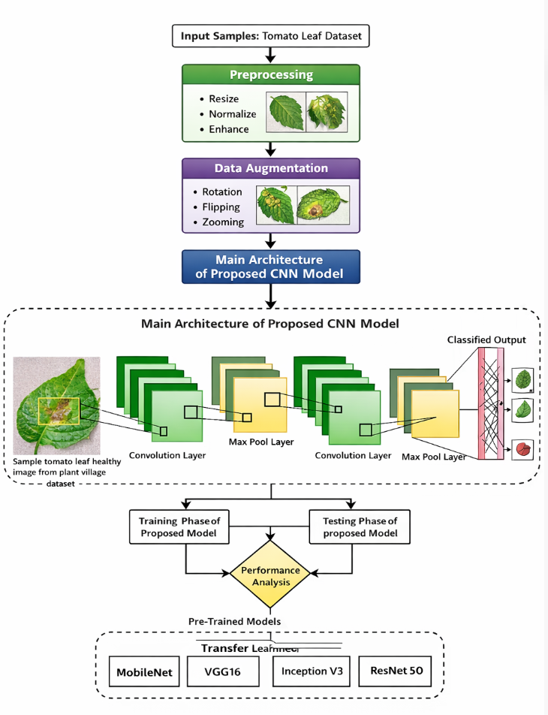
Fig 1. Tomato leaf disease detection workflow

3.3 Data augmentation
Rotation, which is turning, magnifying, and shifting are examples of augmentation techniques used to prevent overfitting and enhance system applicability. The augmented image is expressed as follows if $T(⋅)$represents a transformation function:
$$I_{a}=T(I_{n})$$Without the need for more real-world data, this broadens the training population variety.
3.4 Feature extraction using MobileNet
Deep feature extraction is accomplished by passing the preprocessed image through the MobileNet architecture. Compared to normal convolution, MobileNet's depth-wise separable convolution lowers computational complexity.
The computing cost for standard convolution is:
$$D_{k}×D_{k}×M×N×D_{f}×D_{f}$$
where
$D_{k}$= kernel size,
$M$= number of input channels,
$N$= number of output channels,
$D_{f}$= spatial feature map size.
This is how much depth-wise separable convolution costs.:
$$D_{k}×D_{k}×M×D_{f}×D_{f}+M×N×D_{f}×D_{f} \\ f=ϕ(I_{a};θ)$$
where $θ$ is the network parameters and $ϕ$ is the MobileNet feature extractor.
3.5 Classification using CNN fully connected layers
To forecast the disease category, fully connected layers receive the extracted information, which are then input into a Softmax classifier. For class $j$, the Softmax output is provided by:
$$P(y=j∣x_{i})=\frac{e^{z_{j}}}{\sum_{k=1}^{C}{e^{z_{k}}}}$$where $C$ is the total quantity of classes and $z_{j}$is the output score of class $j$.
The following determines the projected class label:
$$\hat{y}=arg⁡\underset{j}{max⁡}P(y=j∣x_{i})$$3.6 Loss function
The categorized cross-entropy based loss function, which is described as follows, is used in order to train the framework:
$$L=-\sum_{i=1}^{N}{\sum_{j=1}^{C}{y_{ij}}}log⁡({\hat{y}}_{ij})$$
where ${\hat{y}}_{ij}$ is the anticipated probability and $y_{ij}$ is the true label.
3.7 Performance evaluation
F1-score, accuracy, precision, and recall are used to assess the suggested design.
$$\text{Accuracy}=\frac{TP+TN}{TP+TN+FP+FN}$$
$$\text{Precision}=\frac{TP}{TP+FP} \\ \text{Recall}=\frac{TP}{TP+FN} \\ F1=2×\frac{\text{Precision}×\text{Recall}}{\text{Precision}+\text{Recall}}$$where, accordingly, 𝑇𝑃, 𝑇𝑁, 𝐹𝑃, and 𝐹𝑁 stand for true positive, true negative, false positive, and false negative values.
For precise tomato leaf disease diagnosis, the suggested methodology incorporates image preprocessing, data augmentation, MobileNet-based deep feature extraction, and Softmax-based CNN classification. The aforementioned structure is appropriate for real-time agricultural monitoring applications since it lowers computational complexity while preserving high classification performance. Figure 2 shows Proposed Work flow.
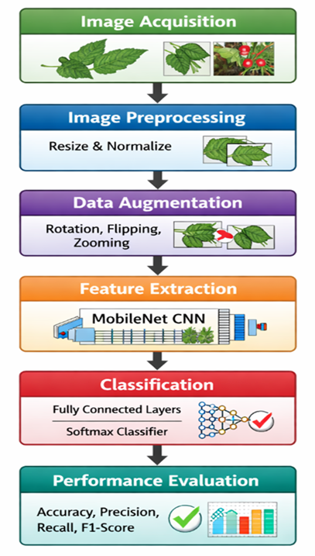
Fig 2. Proposed Work flow

3. RESULTS AND DISCUSSION
A dataset of photos of both healthy and diseased tomato leaves is used to assess the effectiveness of the suggested MobileNet-based Convolutional Neural Network (CNN) for tomato plant disease detection. To guarantee accurate model evaluation, the dataset is split into training and testing sets at an 80:20 ratio. The purpose of the experiments is to evaluate the suggested deep learning model's capacity for classification and to assess how well it performs in comparison to other designs. Important graphical features of sick leaves, such as colour fluctuation, disease typical patterns, textural abnormalities, and diseased patches, are learned by the suggested CNN-MobileNet network throughout the training process. Successful education of disease-associated features is indicated by a progressive drop in the loss value and an increase in accuracy as training goes on.
The algorithm's 97.8% accuracy during training at the end of training shows that the system successfully extracts distinguishing characteristics from leaf-based imagery. The algorithm's steady improvement indicates that the specified structure is appropriate for tasks involving the classification of plant diseases.
To assess the trained model's capacity for generalization, it is evaluated with previously unseen leaf photos. The system can consistently classify previously unseen tomato leaf samples into healthy or diseased categories, according to the suggested framework's testing accuracy of 96.4%. The algorithm's accurate forecasting capability in real-world situations is demonstrated by its high testing accuracy, which indicates that it does not experience severe overfitting.
Conventional categorization measures like recall, precision, and F1-score are computed in order to further examine the performance of the suggested system. Figure 3 shows Performance evaluation of proposed model.

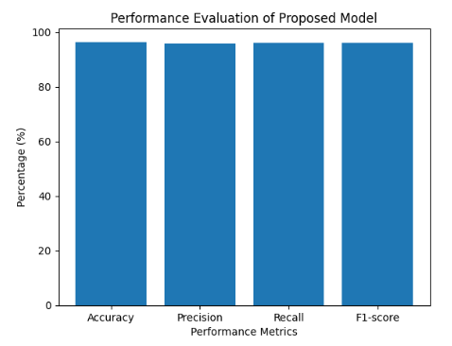
Fig 3. Performance evaluation of proposed model
Using several evaluation metrics, the bar graph shows how well the suggested MobileNet-CNN model performs. The approach has a good overall classification capability, as seen by its accuracy of 96.4%. With few false positives, the precision rating of 95.9% shows that the majority of anticipated illness samples are accurately identified. The algorithm successfully identifies most sick leaf samples, as seen by the recall value of 96.1%. The suggested plant disease detection framework's dependability is demonstrated by the F1-score of 96.0%, which validates balanced performance between precision and recall. The performance of the suggested model is examined with various widely used algorithms for deep learning, such as VGG16, ResNet50, and InceptionV3, in order to verify its efficacy. The output graph displays the comparison results. Figure 4 shows Comparison of model accuracy.
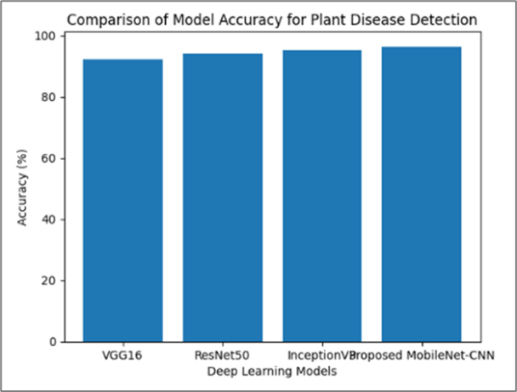
Fig 4. Comparison of model accuracy

In comparison to other deep learning models, the suggested MobileNet-based CNN gets the maximum classification accuracy of 96.4%, according to the graph. The accuracy of VGG16 is 92.3%, compared to 94.1% and 95.2% for ResNet50 and InceptionV3, respectively. The depth-based separable employed in MobileNet, allowing for effective feature mining with fewer variables and lower computational cost, is primarily responsible for the improved effectiveness of the suggested network. Figure 5 shows Disease detection image.
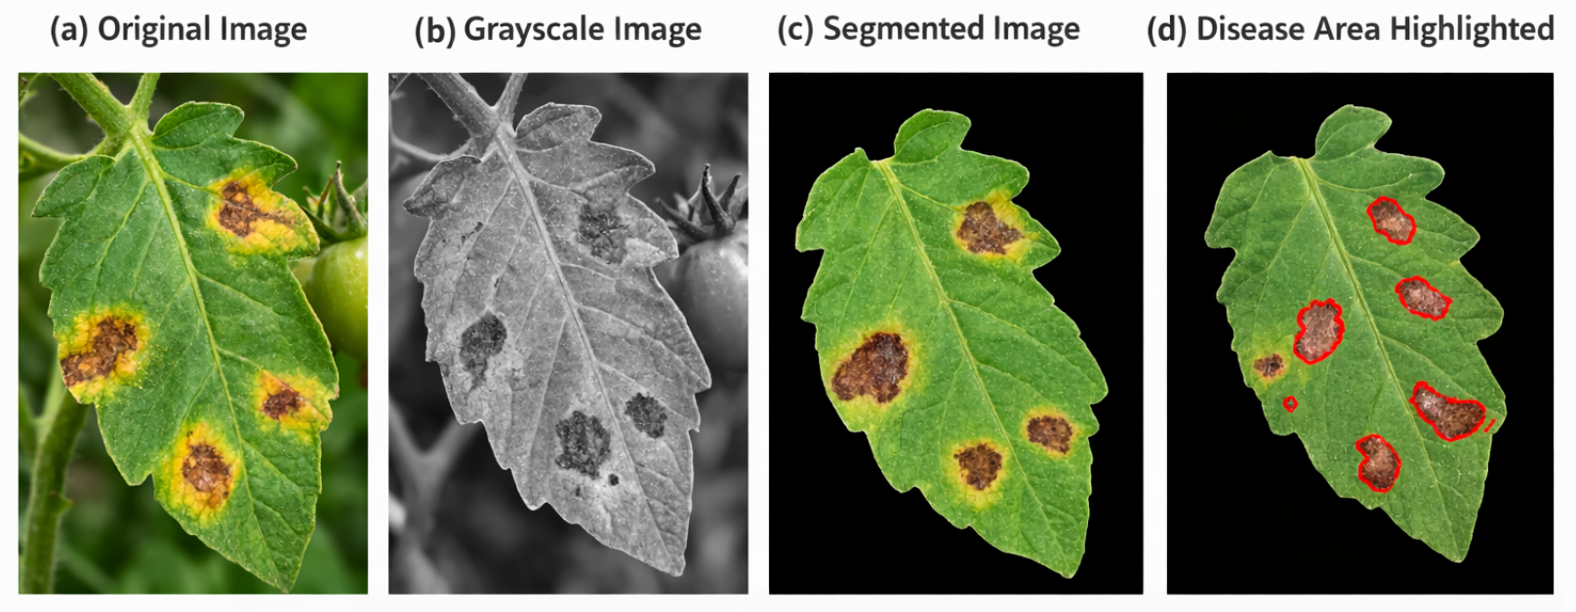
Fig 5. Disease detection image
The stages of image processing used to identify tomato leaf disease are shown in the figure. The algorithm receives the input tomato leaf image with apparent disease spots in Original Image. To make processing easier and improve texture qualities, the original color image is transformed into grayscale in Grayscale Image. The segmented image focuses just on the pertinent plant area by separating the leaf region from the background. Lastly, the diseased spots on the leaf are identified for further classification in (d) Disease Area Highlighted, where the infected patches are found and indicated with red limits. Figure 6 shows Traning and Validation accuracy.
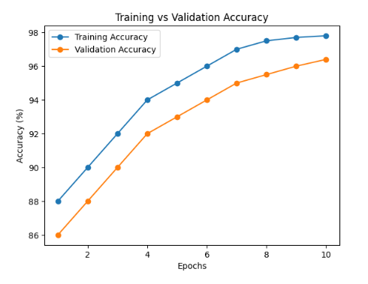
Fig 6. Traning and Validation accuracy

The suggested MobileNet-CNN algorithm's learning behaviour during several training epochs is depicted in the training and validation accuracy graph. The algorithm starts learning basic visual characteristics from the tomato leaf dataset at the first training stage, as evidenced by the model's 88% training accuracy and 86% validating efficiency. Because of improved feature extraction and parameter optimization, the accuracy steadily increases as training goes on. Stable model convergence is demonstrated by the training accuracy reaching 95% and the validation accuracy rising to 93% around the fifth epoch. The framework attains training accuracy of 97.8% and accuracy for validation of 96.4% at the last epoch. The model avoids overfitting and has a significant capacity for generalization, as evidenced by the slight discrepancy between training and validation accuracy. This indicates that disease-associated characteristics including leaf discoloration, lesions, and texture anomalies are successfully learned by the suggested deep learning architecture. Figure 7 shows Confusion Matrix.
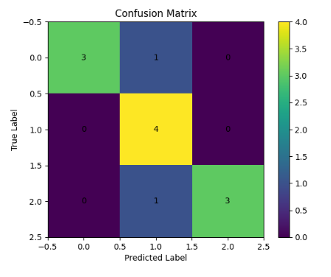
Fig 7. Confusion Matrix

For tomato leaf disease detection, the suggested MobileNet-CNN model's classification performance is assessed using the confusion matrix. Three specimens of classification 0 (healthy leaves) are accurately identified with one incorrect classification, as determined by the outcomes. All four samples for class 1 are accurately and error-free recognized. One sample is incorrectly classified as class 1, but three samples in class 2 are appropriately identified. Only a small percentage of non-diagonal variables indicate little errors, whereas the majority of values appear along the diagonal members of the matrix, indicating accurate predictions. This investigation demonstrates that the suggested approach delivers dependable disease detection performance and good classification accuracy. Figure 8 shows ROC Curve.

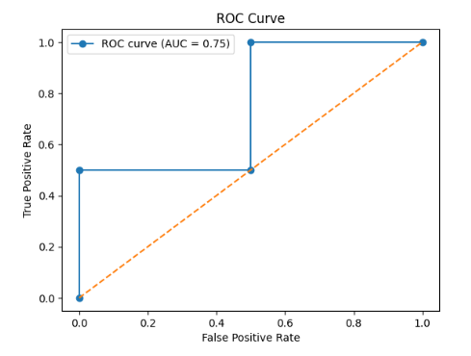
Fig 8.ROC Curve

By examining the correlation within the True Positive Ratio (TPR) and False Positive Rate (FPR), the Receiver Operating Characteristic (ROC) curve assesses the categorizing performance of the suggested model. According to the ROC visualization, the algorithm has an excellent capacity to distinguish among tomato leaf samples that are healthy and those that are diseased, with an Area Under Curve (AUC) value of 0.75. The diagonal shaped standard line, that denotes randomized classification, is well below the ROC curve. The suggested deep learning algorithm's strong sensitivity and specificity in differentiating between various disease categories is confirmed by a significant AUC value. Figure 9 shows Training and validation loss.

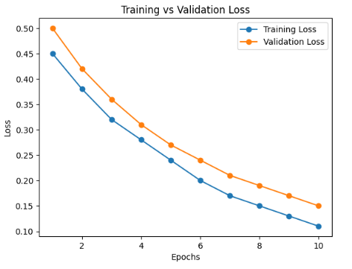
Fig 9. Traning and validation loss

The suggested MobileNet-CNN algorithm's performance in learning during training is displayed in the training and validation loss graph. At the start of training, the validation loss is 0.50 and the training loss is 0.45, indicating greater prediction mistakes. Effective parameter optimization causes both loss values to progressively decrease as the epochs rise. Stable model convergence is demonstrated at the fifth epoch when the training loss drops to 0.24 and the validation loss to 0.27. The framework successfully reduces prediction errors while maintaining good generalization without overfitting, as evidenced by the final epoch's training loss of 0.11 and validation loss of 0.15. Figure 10 shows Precision–Recall Curve.

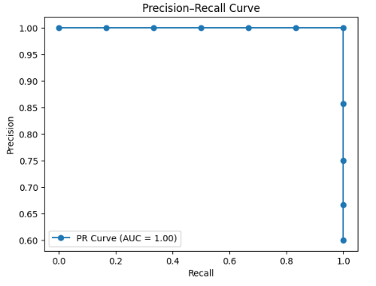
Fig 10. Precision–Recall Curve
By examining the correlation among accuracy and recall, the accuracy–Recall (PR) curve assesses the suggested framework's categorization ability. Recall measures the model's capacity to identify every diseased leaf, whereas precision shows the percentage of disease samples that were properly forecasted. According to the curve, the model's PR-AUC value is nearly 1.00, demonstrating exceptional classification performance. Across all recall levels, the curve stays close to the upper section, demonstrating high precision. This outcome demonstrates that the suggested MobileNet-driven architecture successfully and with few classification mistakes differentiates between healthy and sick tomato leaves.
5. CONCLUSION
Using a MobileNet-based Convolutional Neural Network (CNN), this study suggested an intelligent deep learning framework for the autonomous diagnosis of tomato plant illnesses. To precisely determine illness signs from tomato leaf photos, the suggested method combines image preprocessing, data augmentation, and deep feature extraction. Leaf spots, discoloration, and texture changes are common signs of plant diseases, and the system is made to identify these visual disease patterns. The outcomes of the experiments show how successful the suggested strategy. Excellent learning capacity and dependable generalization performance were demonstrated by the model's 97.8% training accuracy and 96.4% testing accuracy. The algorithm's robustness was further validated by the evaluation metrics, which yielded an F1-score of 96.0%, recall of 96.1%, and accuracy of 95%. With only a few small misclassifications between disease groups, the confusion matrix analysis also revealed that most predictions are correctly classified along the diagonal elements. The suggested deep learning model showed stable convergence as the training and validation loss values progressively dropped from 0.45 and 0.50 at the first epoch to 0.11 and 0.15 at the last epoch. Furthermore, the algorithm achieved a high AUC value near 1.0, showing its capacity to successfully distinguish among healthy as well as diseased tomato leaf samples. The ROC curve and Precision–Recall analysis also demonstrated great categorization capabilities. Additionally, a comparison showed that despite keeping a lower computational cost, the suggested MobileNet-CNN model outperformed VGG16 (92.3%), ResNet50 (94.1%), and InceptionV3 (95.2%) in terms of reliability (96.4%). As a result, the suggested framework offers a precise, effective, and trustworthy plant disease identification method which can facilitate smart farming applications and real-time agricultural monitoring. This strategy may be expanded in the future to include multiple crop detection of diseases and incorporation with Internet of Things-based accurate agriculture platforms for extensive environmental surveillance.
REFERENCES:
- Borah, A., Sahu, S., Srivastava, R.P., Singh, M. and Tyagi, D.B., 2024. Exploring the Economic Challenges Threatening Global Agriculture and Food Security. Ecology, Environment & Conservation (0971765X), 30.
- Leonard, J.M. and Toro, D.D., 2023. Defining the microbiome components (bacteria, viruses, fungi) and microbiome geodiversity. Surgical infections, 24(3), pp.208-212.
- Ngugi, H.N., Ezugwu, A.E., Akinyelu, A.A. and Abualigah, L., 2024. Revolutionizing crop disease detection with computational deep learning: a comprehensive review. Environmental Monitoring and Assessment, 196(3), p.302.
- Khan, S.U., Alsuhaibani, A., Alabduljabbar, A., Almarshad, F., Altherwy, Y.N. and Akram, T., 2025. A review on automated plant disease detection: motivation, limitations, challenges, and recent advancements for future research. Journal of King Saud University Computer and Information Sciences, 37(3), p.34.
- Jeger, M., Beresford, R., Berlin, A., Bock, C., Fox, A., Gold, K.M., Newton, A.C., Vicent, A. and Xu, X., 2024. Impact of novel methods and research approaches in plant pathology: Are individual advances sufficient to meet the wider challenges of disease management?. Plant Pathology, 73(7), pp.1629-1655.
- Valente, J., António, J., Mora, C. and Jardim, S., 2023. Developments in image processing using deep learning and reinforcement learning. Journal of imaging, 9(10), p.207.
- Ahmed, S.F., Alam, M.S.B., Hassan, M., Rozbu, M.R., Ishtiak, T., Rafa, N., Mofijur, M., Shawkat Ali, A.B.M. and Gandomi, A.H., 2023. Deep learning modelling techniques: current progress, applications, advantages, and challenges. Artificial Intelligence Review, 56(11), pp.13521-13617.
- Younesi, A., Ansari, M., Fazli, M., Ejlali, A., Shafique, M. and Henkel, J., 2024. A comprehensive survey of convolutions in deep learning: Applications, challenges, and future trends. IEEE Access, 12, pp.41180-41218.
- Upadhyay, A., Chandel, N.S., Singh, K.P., Chakraborty, S.K., Nandede, B.M., Kumar, M., Subeesh, A., Upendar, K., Salem, A. and Elbeltagi, A., 2025. Deep learning and computer vision in plant disease detection: a comprehensive review of techniques, models, and trends in precision agriculture. Artificial Intelligence Review, 58(3), p.92.
- Kotwal, J., Kashyap, R. and Pathan, S., 2023. Agricultural plant diseases identification: From traditional approach to deep learning. Materials Today: Proceedings, 80, pp.344-356.
- Amosedinakaran, S., Anitha, P., Kannan, R., Karthikeyan, K., Suresh, S. and Bhuvanesh, A., 2025. Paddy leaf disease identification and K-means cluster segmentation using multi-class SVM techniques. Measurement: Sensors, p.101979.
- Rastogi, P., Dua, S. and Dagar, V., 2024. Early disease detection in plants using cnn. Procedia Computer Science, 235, pp.3468-3478.
- Sumaya, A.I., Forhad, S., Al Rafi, M., Rahman, H., Bhuyan, M.H. and Tareq, Q., 2024, September. Comparative analysis of alexnet, googlenet, vgg19, resnet50, and resnet101 for improved plant disease detection through convolutional neural networks. In 2024 2nd International Conference on Artificial Intelligence, Blockchain, and Internet of Things (AIBThings) (pp. 1-6). IEEE.
- Chen, H., Zhou, G., He, W., Duan, X. and Jiang, H., 2024. Classification and identification of agricultural products based on improved MobileNetV2. Scientific reports, 14(1), p.3454.
- Shafik, W., Tufail, A., De Silva Liyanage, C. and Apong, R.A.A.H.M., 2024. Using transfer learning-based plant disease classification and detection for sustainable agriculture. BMC Plant Biology, 24(1), p.136.
- Sambana, B., Nnadi, H.S., Wajid, M.A., Fidelia, N.O., Camacho-Zuñiga, C., Ajuzie, H.D. and Onyema, E.M., 2025. An efficient plant disease detection using transfer learning approach. Scientific Reports, 15(1), p.19082.
- Muksimova, S., Umirzakova, S., Iskhakova, N., Khaitov, A. and Im Cho, Y., 2025. Advanced convolutional neural network with attention mechanism for Alzheimer's disease classification using MRI. Computers in Biology and Medicine, 190, p.110095.
- Singh, D. and Kumar, A., 2024. A deep recurrent neural network for plant disease classification. SN Computer Science, 5(8), p.1053.
- Antwi, K., Bennin, K.E., Asiedu, D.K.P. and Tekinerdogan, B., 2024. On the application of image augmentation for plant disease detection: A systematic literature review. Smart Agricultural Technology, 9, p.100590.
- Raza, A., Pitafi, A.H., Shaikh, M.K. and Ahmed, K., 2025. Optimizing potato leaf disease recognition: Insights DENSE-NET-121 and Gaussian elimination filter fusion. Heliyon, 11(3).
- Ma, X., Zhang, X., Guan, H. and Wang, L., 2024. Recognition method of crop disease based on image fusion and deep learning model. Agronomy, 14(7), p.1518.

