Trade Situation in Turbulent Time of 2025: India’s Economic Outlook in a Volatile World

Prof. Subhendu Bhattacharya, Assistant Professor, Pillai Institute of Management Studies and Research, Navi Mumbai. Email ID- subhendu.b@mes.ac.in

Abstract
In a world characterized by shifting trade alliances, geopolitical conflicts, technology shocks, and climate-related concerns, trade winds are redefining India's economic trajectory in these challenging times. Navigating these complexity presents opportunities as well as challenges for India, one of the major economies with the greatest rate of growth. On the one hand, issues with export performance, inflation control, and fiscal stability are brought on by changes in commodity prices, global supply chain realignments, and growing protectionism. However, India has a solid basis for resilience due to its robust domestic demand, growing digital economy, and policy emphasis on self-reliance and the green transition. The economy's ability to withstand external shocks has been improved by structural reforms in taxation, infrastructure development, renewable energy, and financial inclusion. Meanwhile, programs like Make in India, Production-Linked Incentives (PLI), logistics investment, and trade diversification are designed to further integrate India into global value chains. However, fluctuations in international capital flows, currency exchange rates, and energy markets highlight how precarious short-term prospects are. Accordingly, the future depends on India's capacity to strike a balance between its internal requirements and its foreign commitments, including enhancing regional and bilateral economic ties, advancing technological innovation, and pursuing sustainable growth plans. If handled wisely, India's economic journey has the potential to turn the tumultuous global trade winds into a strategic advantage, allowing it to become more than just a passive player but also a key designer of a new global economic order.
Key Words: Macroeconomic Resilience, Geopolitical Volatility, Fiscal Prudence, Structural Reforms, trade uncertainty, global shocks, Supply chain and logistics, Policy reforms

Introduction
Economic and social system disruptions have been a recurring theme throughout history, but in the modern era, their severity, regularity, and global interconnection have increased. Such disturbances can be broadly divided into two groups: man-made shocks, such as war, tariff limitations, financial crises, and technological advancements, and acts of God, such as pandemics and natural disasters. Both disrupt businesses, governments, and people by interfering with the economy's natural rhythm and necessitating systemic change. Because of today's integrated markets, a disruption in one area can have a global impact, increasing the risks and opportunities. One of the biggest disruptions of the twenty-first century was the COVID-19 pandemic, which disrupted supply chains, strained healthcare systems, and stopped mobility. As a "Act of God," it illustrated how susceptible contemporary economies are to biological shocks that are difficult to forecast but can have far-reaching effects. The vulnerability of international systems that depend on just-in-time manufacturing and open borders was brought to light by market contractions, increases in unemployment, and fiscal imbalances. Paradoxically, though, the pandemic also demonstrated resilience through e-commerce, telemedicine, remote learning, and increased digitization—a quintessential illustration of how shocks devastate some industries while spurring growth in others. Warfare and other man-made disruptions have continued to be persistent aspects of world instability. For instance, the conflict between Russia and Ukraine had a devastating impact on the economies of the parties directly involved as well as having a ripple effect on inflation, food security, and oil prices worldwide. Similarly, a possible confrontation between technologically advanced nations or an increase in Middle East tensions has an impact on global value chains and financial markets. In addition to causing physical devastation, warfare disrupts trade, investment flows, and multilateral collaboration by imposing a protracted sense of uncertainty. Another intentional, man-made disruption of economic activity is the imposition of tariff limitations. Tariffs, as opposed to wars or health crises, are policy decisions that indicate a move toward economic nationalism and protectionism. Global supply chains were upset by the U.S.-China trade war in the late 2010s, which compelled multinational corporations to reevaluate their reliance on a single market and diversify their manufacturing bases. Despite being viewed as economic interventions, tariffs have the potential to destabilize the global trading system by causing long-term inefficiencies, higher consumer costs, and retaliatory spirals. The Black Swan effect, as proposed by Nassim Nicholas Taleb, has had a significant impact on our understanding of disruptions. Taleb makes the case in his groundbreaking book The Black Swan: The Impact of the Highly Improbable that some events are extreme outliers that are hard to forecast but have enormous repercussions once they do. The COVID-19 epidemic, the September 11 attacks, and the global financial crisis of 2008 are a few examples. In addition to being disruptive, these occurrences also call into question human tendencies to assume stability and linearity in forecasting. Furthermore, fundamental flaws that go undetected in "normal" times—whether in healthcare systems, financial markets, or geopolitical alliances—are revealed by Black Swan events. Disruptions may represent what economist Joseph Schumpeter called "creative destruction," even if they frequently have negative connotations. Schumpeter argues that the demise of antiquated institutions, industries, and practices is essential to economic advancement because it makes room for new, more effective systems. This approach is exemplified by the automation of manual clerical work and the replacement of coal with renewable energy. By requiring quick adaptation, encouraging innovation, and redistributing resources to new industries, pandemics, wars, and trade disputes frequently hasten creative destruction. As a result, destruction and renewal are linked, indicating that disruption can act as a stimulus for long-term productivity development even though it is unpleasant. The business cycle, which is the inherent rhythm of expansions, peaks, recessions, and recoveries in capitalist economies, is closely related to all of these occurrences. Frequently, disruptions function as catalysts that cause economies to go from expansion to decline. For example, a lengthy economic cycle was abruptly stopped by the global financial crisis of 2008, and expectations of affluence were shattered by the pandemic-induced recession of 2020. However, economies usually return to periods of expansion and recovery through structural changes, monetary relaxation, and fiscal stimulus. Importantly, the extent and length of each contraction are determined by the institutions' flexibility and receptivity to change, in addition to the magnitude of the disturbance. Thus, the cycle illustrates both the intrinsic resilience of economic systems and their susceptibility to shock.
Although India's economy is expected to grow rapidly in 2025, it will confront several challenges from global polarization, the Trump administration's harsh tariff limitations, persistent geopolitical tensions, and widespread supply chain disruptions. Since the United States, India's biggest trading partner until recently, imposed a high 50% tax on Indian exports, Indian goods like textiles, electronics, and diamonds have become less competitive, and hundreds of thousands of jobs in export-driven industries are at risk. Even though the total impact on GDP is only expected to be about 1%, officials are quickly adjusting their trade policies, giving domestic consumption top priority, and looking for new markets through bilateral and multilateral agreements. Geopolitical unrest, such as the Middle East conflict and border disputes with neighboring nations, has revealed weaknesses in India's supply chains, particularly in the manufacturing and energy sectors. Major marine route disruptions have raised shipping prices and caused export delays, affecting vital sectors like equipment, agriculture, and medicines. Despite these obstacles, India has managed to hold onto its position as one of the major economies with the fastest rates of growth in the world, with a forecast GDP growth of 6.4–6.5% because to its strong domestic market, continuous digital transformation, and strong reform momentum. India is concentrating on bolstering self-reliance (Aatmanirbhar Bharat), diversifying supply chains, speeding investments in renewable energy, and establishing ties with alternative partners in the Indo-Pacific and the global South in response to global division and fragmentation. India's future in an increasingly unstable climate will depend on its capacity to innovate and adapt as global trade patterns change.
Objective of the study
The key objectives for the research paper are as follows.
- To critically analyze the impact of global polarization, tariff restrictions, and geopolitical tensions on India’s trade performance and overall economic stability during 2025.
- To evaluate India’s adaptive strategies in mitigating supply chain disruptions and sustaining economic growth under heightened external volatility.
Literature Review
The research on India's economic prospects in the face of tumultuous international circumstances from 2020 to 2025 shows a complicated interaction between resilience at home and foreign shocks. Growing geopolitical tensions have caused major supply chain and financial sector instability, endangering India's macroeconomic stability, claim Kumar and Rao (2023). Despite trade disputes and international unpredictability, India's GDP has grown steadily at a rate of about 6.5%, according to the Economic Survey (2025), highlighting robust domestic demand and reform momentum. Biswas and Das (2020) highlight how the COVID-19 pandemic disrupted supply chains, citing labor shortages and logistical inefficiencies as the main obstacles and suggesting digital transformation for resilience. George (2025) delves more into the combined effects of supply disruptions and tariffs on vital industries like medicines, which rely significantly on imported goods. Singh et al. (2025) assess the Trump administration's tariffs and note that while there has been some growth in services as a result of currency depreciation, there have been considerable negative effects on employment in export-dependent businesses. In reaction to global shocks, PWC India (2023) highlights the push for Indian companies to restructure supply chains using diversified sources and predictive algorithms. India's economy is expected to grow modestly, according to the OECD's 2025 forecast, but trade protectionism and geopolitical instability pose serious threats. As long as India improves its export competitiveness, the "Trump shock" tariff measures are disruptive but manageable, according to the National Institute of Public Finance and Policy (NIPFP, 2025). Nair and Goswami (2023) provide examples of how PLI schemes and other government incentives support supply chain resilience and industry revival under pressure. India's expanding consumer base and digital usage are praised by the World Bank (2025) as barriers against external shocks, while Imaduddin and Verma (2024) caution about the dangers of rising inflation and credit tightening brought on by geopolitical crises. Finally, the balancing act between taking advantage of international trade opportunities and protecting against vulnerabilities within India's changing economic architecture is emphasized by the Department of Economic Affairs (2025). All together, these works present India's economic path as cautiously optimistic, bounded by outside uncertainties but supported by proactive policy and structural flexibility. The Black Swan theory, developed by Nassim Nicholas Taleb(2007), emphasized how sporadic, erratic occurrences such as financial crises or pandemics cause extreme instability, highlighting the vulnerability of economic systems and the limitations of forecasting. These occurrences cause market meltdowns and necessitate quick company and policy reactions. In a similar vein, Joseph Schumpeter's theory(1942) of creative destruction explained how innovation spurs long-term prosperity while temporarily upending sectors, occupations, and skill sets. These ideas collectively highlight unpredictability, resilience, and adaptation: shocks cause economic instability but also encourage rebirth, forcing society to embrace adaptability and creativity in order to endure and prosper in the face of change and uncertainty.
Theoretical Construct
Trade is the primary driver of economic growth, according to the theoretical framework underlying the research study "Trade Wind in Turbulent Time: India's Economic Outlook in a Volatile World." Both classical economists and modern trade theorists, who highlight specialization and comparative advantage as key factors in wealth, have studied this idea in great detail. Adam Smith developed the notion of absolute advantage in 1776, arguing that in order to maximize wealth, countries should manufacture things more effectively than others and engage in free commerce. This was furthered by David Ricardo (1817), who developed the theory of comparative advantage, which demonstrates that when nations specialize in items where they have relative efficiency, mutually beneficial trade results, even if one nation is more efficient at producing all goods. This is further explained by the Heckscher-Ohlin model, which places a strong emphasis on factor endowments and proposes that nations buy items that require scarce factors and export those that require ample factors. Today, the idea of first-mover advantage describes how innovators or early adopters in international marketplaces use network effects, branding, and technology to gain long-term competitive advantages. Global supply chains and economic integration have been fostered by the dismantling of trade barriers and the facilitation of liberalization brought about by the 20th century's acceleration of trade and globalization, which has been supported by institutional frameworks like the World Trade Organization (WTO) and coordinated efforts by the United Nations Conference on Trade and Development (UNCTAD). But with countries striking a balance between openness and strategic autonomy, innovation, and resilience, the modern geopolitical landscape calls into question established free trade models. This theoretical framework highlights how India's economic viewpoint is shaped by the dynamic interaction of traditional trade principles and changing global complications in the face of instability.
Data Analysis and Interpretation
Table I: Indian Trade in Merchandise and Service (YoY basis)
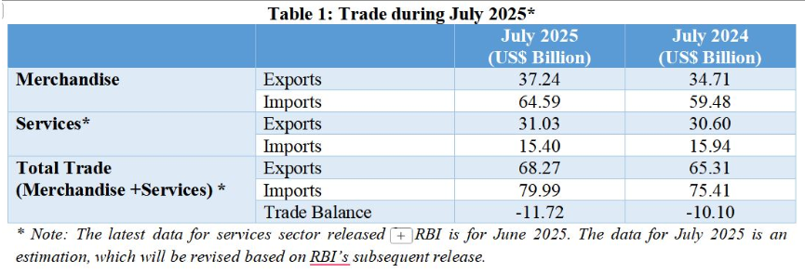
Source: Ministry of Commerce & Industry, GoI, July 2025
The table shows India’s trade performance in July 2025 compared with July 2024. Merchandise exports rose to $37.24 billion from $34.71 billion, while imports increased more sharply to $64.59 billion from $59.48 billion. In services, exports were slightly higher at $31.03 billion versus $30.60 billion, but imports fell marginally to $15.40 billion from $15.94 billion. Overall, total exports (merchandise + services) reached $68.27 billion, up from $65.31 billion, while imports climbed to $79.99 billion from $75.41 billion. Consequently, the trade deficit widened to $11.72 billion in July 2025 compared to $10.10 billion a year earlier. Geopolitical tension, tariff restriction, trade disruption and supply chain problem due to ongoing warfare had some detrimental effects on bilateral and multilateral trade.
Diagram I: Export and Import of commodities and status with respect to other nations
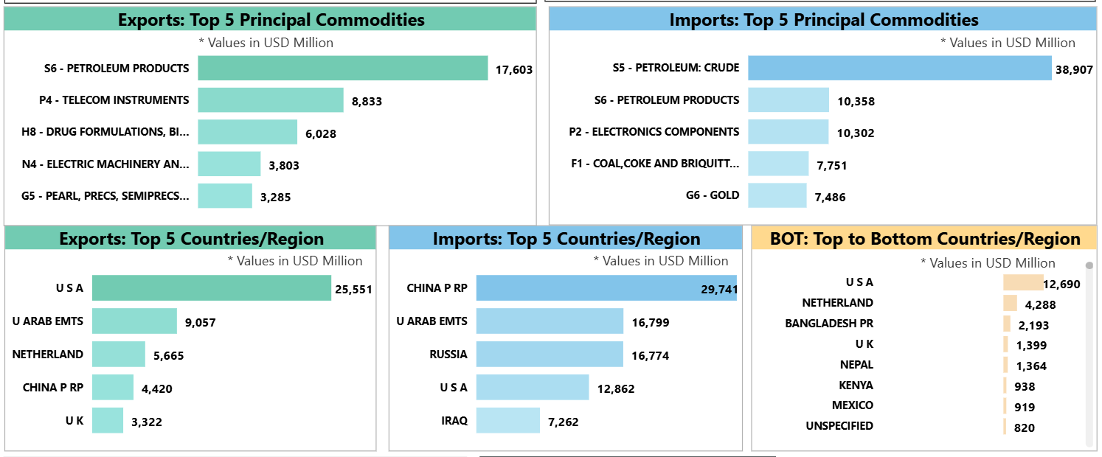
Source: Ministry of Commerce & Industry, GoI, Sept 4, 2025
The bar diagrams show India’s trade profile, highlighting that petroleum products dominate exports ($17,603 million), followed by telecom instruments and drug formulations, while crude oil overwhelmingly leads imports ($38,907 million) along with petroleum products, electronics, coal, and gold. The USA is India’s top export destination ($25,551 million), far ahead of the UAE and Netherlands, whereas China is the largest import source ($29,741 million), followed by the UAE, Russia, the USA, and Iraq. In terms of trade balance, India enjoys its highest surplus with the USA ($12,690 million), with smaller surpluses from the Netherlands, Bangladesh, the UK, Nepal, and others.

Table II: Major Destinations of Export of Top 10 Principal Commodities (April-Sep, 2024-25)
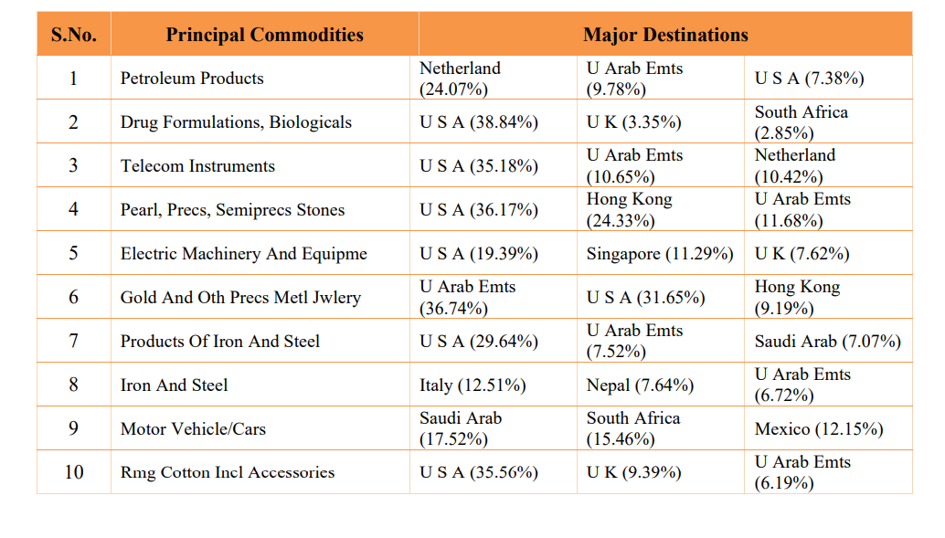
Source: Monthly bulletin on Foreign Trade Statistics, Ministry of Commerce and Industry, Department of Commerce, DGFT, Government of India, Oct 2025
India's top 10 export commodities and their three main destination markets for April–September 2024–2025 are highlighted in the table, which shows distinct trends in the demand for Indian goods around the world. Pharmaceuticals (38.84%), telecom instruments (35.18%), pearls and precious stones (36.17%), gold and precious metal jewelry (36.74%), electric machinery (19.39%), and ready-made cotton clothing (35.56%) are just a few of the commodities for which the US is the top destination. The strong commercial ties between India and the Gulf region are also shown in the United Arab Emirates' frequent appearance as a major buyer, especially for petroleum goods (9.78%), telecom equipment (10.65%), jewelry (31.65%), iron and steel products (7.52%), and cotton clothing (6.19%). Europe's significance for both industrial and value-added goods is demonstrated by the prominence of European markets like the Netherlands, Italy, and the UK for commodities like petroleum (24.07%), telecom equipment (10.42%), iron and steel (12.51%), and clothing (9.39%). Asian commercial hubs like Hong Kong and Singapore are significant contributors to the global re-export and distribution of gems and jewelry (24.33% and 9.19%) and electric machinery (11.29%). As a result of India's increasing export diversification throughout Africa, the Middle East, and Latin America, nations like South Africa, Saudi Arabia, Mexico, and Nepal also seem to be important destinations, especially for autos, metals, and steel. Overall, the table shows that India's export profile is commodity-specific and geographically diverse, with a significant concentration in important international markets and steady growth into emerging economies.
Diagram II: Export of Top 10 Commodities during April- Sep 2024-25
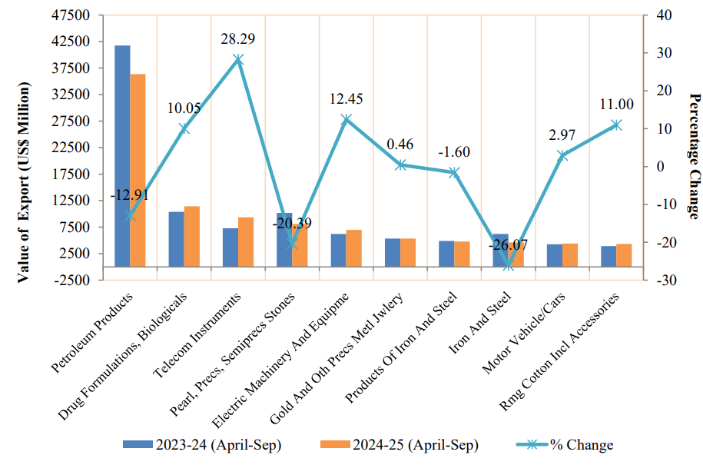
Source: Monthly bulletin on Foreign Trade Statistics, Ministry of Commerce and Industry, Department of Commerce, DGFT, Government of India, Oct 2025
When comparing the export performance of India's top 10 commodities from April to September of 2024–2025 to the same period in 2023–2024, the diagram shows varied tendencies with significant differences in both export values and growth rates. Despite being the largest export category, petroleum products exhibit a notable fall of –12.91%, suggesting either price corrections or reduced global demand. Drug formulations and biologicals, on the other hand, show a robust positive rise of 10.05%, indicating India's expanding pharmaceutical footprint. With an astounding 28.29% increase, telecom instruments emerge as the fastest-growing category, indicating increased demand for Indian electronics and communication gear. Jewelry exports (gold and other precious metal jewelry) continue to increase at a modest rate of 12.45%, while pearls and other precious and semiprecious stones see a sharp decline of –20.39%. While iron and steel as a raw category shows a loss of –1.60%, demonstrating sectoral unevenness, iron and steel products show a slight recovery at 0.46%. Due to steady demand for automobiles in outside markets, motor vehicles/cars show a slight positive growth of 2.97%. In the intervening time, ready-made cotton clothing and accessories saw a strong 11% increase, indicating that India's textile and clothing exports are resilient. Overall, the graph highlights changing global market dynamics and commodity-specific demand patterns by contrasting high-growth industries like telecom instruments, pharmaceuticals, jewelry, and clothing with declines in petroleum, gems and stones, and some metal categories.
Geopolitical Shifts and Their Implications for Indian Trade
The global trade landscape has been drastically reshaped by geopolitical changes in 2025, which have had a significant impact on Indian trade. There have been immediate setbacks as a result of the Trump administration's 50% tariff on Indian exports, which include medicines, textiles, gems and jewelry, and smart devices. Export orders have been halted, and industry leaders have warned of a sharp 70–75% drop in shipments to the US and the loss of many jobs in important industries like IT services, jewelry, and textiles. In addition to endangering India's hegemonic market dominance in the US, the competitive disadvantage brought about by these tariffs has compelled exporters to think about moving their manufacture to nations like Dubai and Mexico in order to lessen the effects. In particular, the textile and garment industries are facing previously unheard-of difficulties. Their narrow profit margins make it impossible for MSMEs to absorb cost increases and keep their loyal US customers. Indian trade organizations and authorities are desperately looking for strategic alternatives to these restrictions and growing protectionism. With leaders agreeing to speed up connectivity projects, resume border trade, and investigate preferential access across Eurasian corridors, the Shanghai Cooperation Organization (SCO) Summit 2025 has provided India with timely opportunities to strengthen regional cooperation with China, Russia, Central Asia, and new members from Eurasia. In an effort to offset Western restrictions and diversify its export base, India is also working to increase commercial relations with East Asia and Europe. In a world that is becoming more multipolar and unstable, India's ability to adapt through policy support, alternative markets, and regional integration will determine its resilience, global significance, and future economic trajectory as traditional trade channels become more restricted.

Policy Reforms: From Self-Reliance to Global Competitiveness
India has strategically moved from self-reliance (Aatmanirbhar Bharat) to export-oriented production and aspirational global competitiveness in its policy reform trajectory from 2020 to 2025. With programs like Make in India and Production-Linked Incentives (PLI) promoting capacity building and technology adoption, the government gave priority to domestic production in industries like electronics, textiles, and defense. As India expanded to more than 100 international markets and indigenized over 3,000 commodities, exports in defense production alone reached all-time highs. MSMEs and start-ups have benefited from targeted assistance for skill development and digital transformation, which has strengthened supply chains even more by promoting frameworks that are driven by innovation and the market. Liberalized foreign direct investment (FDI) regulations, a number of dynamic new free trade agreements (FTAs) with partners in the UK, Australia, the United Arab Emirates, and the ASEAN area, and the revision of the Foreign Trade Policy (FTP) with the goal of doubling exports to $2 trillion by 2030 are all examples of export expansion initiatives. In the India–UK Free Trade Agreement 2025, India obtained duty-free access for the majority of its exports, removing market and visa restrictions for Indian service workers. Together with streamlined trade processes, digital public infrastructure projects like Bharat Trade Net and ONDC have improved the ease of doing business for Indian companies and established a smooth export ecosystem. India has become one of the most cost-effective manufacturing and export hubs in the world thanks to strategic policy changes, strong incentives, and growing global integration. This has strengthened India's place in global supply chains and paved the road for its $5 trillion economic goals.
Manufacturing Powerhouse, Infrastructure Reinforcement, and Supply Chain Realignments for India
India is positioned as a crucial link in global supply networks thanks to its ambitious goal to become a global manufacturing hub, which is based on strong infrastructure reinforcement and extensive supply chain reconfiguration. With over $100 billion in foreign direct investment (FDI) anticipated by 2025 as multinational corporations increase local production capabilities in industries ranging from electronics and pharmaceuticals to automotive and textiles, government-led programs like Make in India and the Production Linked Incentive (PLI) scheme have stimulated investment and technological advancements. Modern ports, airports, railroads, and industrial corridors are just a few examples of the infrastructure improvements that have increased connectivity, decreased logistics costs, and improved efficiency, allowing manufacturers to easily sell to other markets and satisfy international standards. This tendency is best illustrated by emerging industrial centers such as Chennai, Pune, Ahmedabad, and Gujarat, where specialized clusters encourage innovation and skill development that strengthen supply chains' resilience and depth. The sector's competitiveness and adaptability in uncertain times are further enhanced by the broad adoption of automation, environmentally friendly methods, and smart production (Industry 4.0). India is lowering its risk exposure and strengthening its reputation as a reliable alternative to Asia's established industrial behemoths by promoting supply chain diversification and cooperation with carefully chosen local and foreign partners. By 2025, India's manufacturing sector is expected to account for almost 25% of its GDP, bolstering both its domestic economy and its position as a vital participant in the changing global supply chain architecture.
Conclusion

Driven by changing global alliances and tariffs, India has stepped up attempts to diversify its export markets and develop strategic relationships in response to a more unpredictable trade climate and a world that is becoming more multipolar. India's vulnerability to concentrated market dependency has been highlighted by US tariffs since August 2025, which has led the government and industry to actively seek alternate destinations in Asia, Europe, Africa, and Latin America in order to absorb export surpluses and stabilize revenues. Thirteen new Free Trade Agreements (FTAs) have been concluded in recent years, including significant agreements with the UK, UAE, and Australia. These agreements grant duty-free access to most tariff lines for Indian exporters and grow industries including textiles, IT, healthcare, and agriculture. In order to prevent protectionist forces in established Western markets from impeding India's growth trajectory, ongoing negotiations with the EU, New Zealand, and GCC nations seek to further abolish tariff and non-tariff barriers. Indian companies are able to modify their product portfolios, acquire new clients, and establish technological alliances in high-growth areas thanks to proactive market intelligence, sectoral assistance for MSMEs, and trade facilitation programs (like the Export Promotion Mission and digital infrastructure improvements). In order to strike a balance between strategic autonomy and global integration, the government of India has also backed reciprocal tariff responses and import substitution when necessary. In the face of growing geopolitical complexity, this diverse, partnership-driven strategy puts India in a position to not just reduce risks but also to take advantage of new opportunities in global supply chains and guarantee steady export-led growth.

References

- Biswas, T. K., & Das, M. C. (2020). Selection of the barriers of supply chain management in Indian manufacturing sectors due to COVID-19 impacts. Operational Research in Engineering Sciences: Theory and Applications, 3(3), 1-12.
- Department of Economic Affairs. (2025). India's Economic Survey 2024-25. Ministry of Finance, Government of India.
- Department of Economic Affairs. (2025). Monthly Economic Review, May 2025. Ministry of Finance, Government of India.
- George, S. (2025). Navigating tariffs and supply chain disruptions: An analysis of pharmaceutical sector impacts. International Journal of Industrial Research, 12(1), 45-62.
- Imaduddin, M., & Verma, P. (2024). Inflationary pressures and credit tightening amid geopolitical tensions: India's economic challenges. Journal of Asian Economics, 58(4), 210-225.
- Kumar, A., & Rao, S. (2023). Assessing and mitigating the impact of geopolitical risk uncertainty on the Indian financial sector. Bulletin of Monetary Economics and Banking, 25(4), 480-495.
- Nair, A., & Goswami, S. (2023). The role of government incentives in industrial recovery post-global shocks: Evidence from India. Journal of Development Policy Studies, 15(2), 123-143.
- National Institute of Public Finance and Policy (NIPFP). (2025). Impact of Trump shock on Indian economy: An assessment. Economic Policy Review, 37(1), 58-75.
- OECD. (2025). India economic outlook 2025. OECD Economic Outlook, Volume 2025 Issue 1, 75-92.
- PWC India. (2023). Paradigm shift in supply chain management: Lessons for Indian firms. PWC Research Publications, 22(2), 30-49.
- Schumpeter, J. A. (1942). Capitalism, Socialism and Democracy. Harper & Brothers.
- Singh, R., Sharma, V., & Menon, A. (2025). The effects of US tariffs on Indian export sectors and employment. International Trade Journal, 45(3), 289-305.
- Taleb, N. N. (2007). The Black Swan: The Impact of the Highly Improbable. Random House.
- World Bank. (2025). India overview: Growth and governance. World Bank Economic Review, 40(1), 15-38.

